Root Origin
(E-commerce Website)
Software Requirements Specification INT 222
ADVANCED WEB DEVELOPMENT
Name: Chaitanya G (12320480)

Team:
Md Sufiyan
Mahesh Routhu
Shubham Pradhan

Regno: Chaitanya G:12320480

Team:
Md Sufiyan:12316614
Mahesh Routhu:12413072
Shubham Pradhan:12311700

STUDENT GROUP DETAILS
Names | Chaitanya Gollavilli, Shubham Pradhan, Mahesh Routhu, Mohammed Sufiyan Pasha
Roll Numbers | 49, 57, 59, 63
Registration Numbers | 12320480, 12311700,12313072, 12316614
Emails | chaitanyag1718@gmail.com, sagark78007@gmail.com, maheshrouthu804@gmail.com, pashasufiyan321@gmail.com
CLIENT DETAILS
Name | N. Satya Narayana
Email (Official) | satyanarayana153939@gmail.com
Contact Number (Official) | 9247874590
Organization/Company Address | SATYANARAYANA AGENCIES / YELLAMANCHILI-531055, VISAKHAPATNAM, ANDHRAPRADESH
REQUIRED DOCUMENT DETAILS (Yes/No)
GST No. | 37NRFPS0094M1ZW
Email Acknowledgement | Yes / link: https://drive.google.com/drive/folders/1vxFSyTQ9Rtn1x30389BYh-93ES_V5zli?usp=sharing
Client Organization location proof (Google Maps) | https://maps.app.goo.gl/52bRphZAsF1kFKvV8 [ COURT ROAD, BEISDE URBAN POLICE STATION, YELLAMANCHILI-531055, VISHAKAPATNAM]
Transaction ID proof | T2512302159589017204012 / Link: https://drive.google.com/drive/folders/1vxFSyTQ9Rtn1x30389BYh-93ES_V5zli?usp=sharing

CLIENT APPROVAL FORMAT (REVENUE GENERATION PROJECTS)

PROJECT SUMMARY
Title and | ROOT ORIGIN (e-commerce application designed for online retail and bulk order management. The platform allows users to browse products, apply discounts, manage carts, place orders using multiple payment methods, and track order history. It also includes an admin dashboard for product management, order tracking, analytics visualization, and invoice generation, making it suitable for both regular and event-based bulk purchases built for enterprise business.)
Revenue generated (Rs.) | 8000/-
Deployed Link | https://root-origin.vercel.app/
GitHub link | https://github.com/chaitanya1718/ROOT-ORIGIN
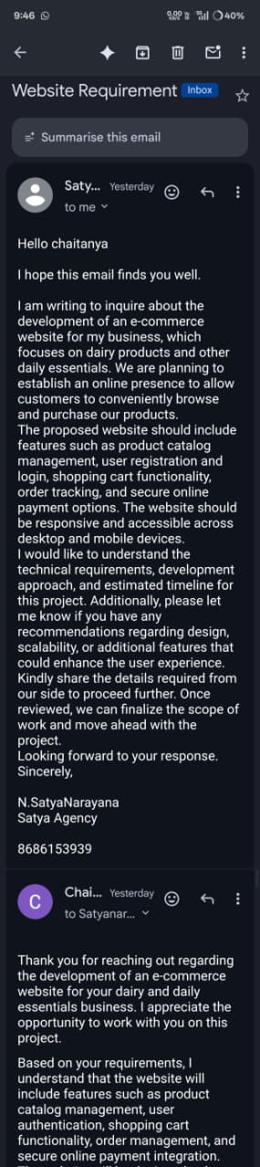
email acknowledgement payment proof
ACCEPTANCE OF PROPOSAL
Authorized Client Signature/ E-Signature | DATE OF ACCEPTANCE


Table of Contents
REVISION HISTORY ..................................................................................................................................................
- INTRODUCTION 3
  - Purpose 3
  - Scope 3
  - Definitions, Acronyms, and Abbreviations 3
  - References 4
  - Overview 4
- GENERAL DESCRIPTION 4
  - Product Perspective 4
  - Product Functions 4
  - User Characteristics 4
  - General Constraints 5
  - Assumptions and Dependencies 4
- SPECIFIC REQUIREMENTS 6
  - External Interface Requirements 6
    - User Interfaces 6
    - Hardware Interfaces 7
    - Software Interfaces 7
    - Communications Interfaces 7
  - Functional Requirements 6
    - <Functional Requirement or Feature #1> 6
    - <Functional Requirement or Feature #2> 7
    - <Functional Requirement or Feature #> 7
    - <Functional Requirement or Feature #4> 8
    - <Functional Requirement or Feature #5> 8
    - <Functional Requirement or Feature #6> 9
    - <Functional Requirement or Feature #7> 10
  - Non-Functional Requirements 11
    - Performance 11
    - Reliability 12
    - Availability 12
    - Security 13
    - Maintainability 13
    - Portability 14
3.7 Design Constraints 14
3.9 Other Requirements 15
- ANALYSIS MODELS 15
  - Data Flow Diagrams (DFD) 15
- GITHUB LINK 16
- DEPLOYED LINK 16
- APPENDICES 17
  - APPENDIX 1 17
  - APPENDIX 2 17

Introduction
The E-Commerce Management System is a full-stack web application designed to enable users to browse products, manage carts, place orders, and make payments through multiple methods. The platform also provides an administrative dashboard to manage products, orders, analytics, and customer interactions. This system bridges the gap between customers and sellers by offering a centralized, efficient, and scalable online shopping solution.

Purpose
The E-Commerce Management System is a full-stack web application designed to enable users to browse products, manage carts, place orders, and make payments through multiple methods. The platform also provides an administrative dashboard to manage products, orders, analytics, and customer interactions. This system bridges the gap between customers and sellers by offering a centralized, efficient, and scalable online shopping solution

Scope
The application aims to provide complete online shopping experience for customers and a powerful management interface for administrators.
This system will:
- allow users to browse and search products by name, category, and tag
- enable users to add products to cart and place orders
- support multiple payment methods including Cash on Delivery and online payments (Razorpay test mode)
- provide order tracking and invoice generation
- offer admin-level analytics for sales, revenue, and product performance

In Scope
• User registration with email verification (OTP-based)
• Secure login for users and administrators
• Product listing with pricing, discounts, and bulk purchase options
• Cart management and checkout flow
• Order placement, tracking, and invoice generation
• Admin dashboard with product CRUD operations
• Order management and status updates
• Sales analytics with charts (pie and bar charts)

Out of Scope (for now)
• Live delivery tracking
• Refund and return workflows
• Automatic address and location detection
• Real payment settlement (only test mode used)

Definitions, Acronyms, and Abbreviations
- UI: User Interface
- API: Application Programming Interface
- DB: Database
- CRUD: Create, Read, Update, Delete
- JWT: JSON Web Token
- OTP: One-Time Password
- MERN: MongoDB, Express.js, React.js, Node.js
- COD: Cash on Delivery

References
- React documentation
- Node.js and Express documentation
- MongoDB & Mongoose documentation
- Razorpay Payment Gateway documentation

Overview
- Section 2 explains the product perspective, functions, users, and constraints.
- Section 3 lists all functional and non-functional requirements.
- Section 4 explains analytics and data flow.
- Sections 5–6 describe deployment and repository details.

General Description

Product Perspective
This is a standalone web application with a client-server architecture:
- Frontend: React (Vite) with component-based UI
- Backend: Node.js + Express (REST API)
- Database: MongoDB (Mongoose ODM)
- Authentication: JWT-based authentication with role control
- Authentication: JWT-based authentication with role control

Product Functions
Main functions include:
- User registration with OTP email verification
- User and admin login
- Product listing management (add/edit/delete)
- Product search by keyword and filters
- Checkout and order placement
- Payment selection(COD/Online)
- Invoice PDF generation and email delivery
- Admin product management(add/edit/delete)
- Order status management
- Sales analytics (based on category and items)

User Characteristics
Customer:
- Signup and login
- Basic technical knowledge
- Uses web browser or mobile device
- Can browse products, place orders, and track purchases
Αdmin:
- Higher technical understanding
- Manage products, orders and analytics
- Monitors business performance and customer activity

General Constraints
- Must support latest versions of Chrome/Edge/Firefox
- Must be responsive for mobile and desktop
- Payment gateway limited to test environment
- Secure routes using authentication and authorization
- Analytics must load efficiently with pagination and lazy loading

Assumptions and Dependencies
- Users have internet connectivity
- Product details entered by admin are accurate
- Email services are available for otp and invoice delivery
- Razorpay test keys are correctly configured
- Analytics data depends on order and product records

Specific Requirements

External Interface Requirements

User Interfaces

Customer UI Pages
      - Home/Search
        - Product listing with categories and carousels
        - Search bar for product name, category, or tags
        - Highlighted deals (discounted products)
        - Navigation to cart, account, and orders

Search Results
        - Dynamic product listing based on search input
        - Filters:
        - Category
        - Discounted products
        - Bulk products (event-based orders)
        - Real-time search suggestions dropdown

Product Details
        - Product name, image, price, discount, and final price
        - Measurement unit and stock availability
        - “Add to Cart” button
        - Out-of-stock indication

Cart
        - List of added products with quantity
        - Price calculation with discounts
        - Remove or update quantity
        - Proceed to checkout

Checkout
- Address selection (add/edit/delete address)
- Payment method selection:
- Cash on Delivery
- UPI (Razorpay test mode)
- Card (Razorpay test mode
- Order summary with total amount
- Place order confirmation

6. Orders

- Owner Dashboard
  - List of past orders
  - Order status (Placed / Shipped / Delivered / Cancelled)
  - Invoice download option

7. Login / Register
- Email-based registration with OTP verification
- Secure login using email and password
- Forgot password with email reset link
Admin UI Pages
1. Admin Dashboard
- Overview of total orders, products, and revenue
- Pie chart showing category-wise sales distribution
- Clickable chart slices to view detailed analytics
2. Analytics Page
- Bar charts showing:
- Quantity sold
- Revenue generated
- Filter by category
- Toggle between revenue and quantity metrics
3. Product Management
- Add new product
- Edit existing product
- Delete product
- Bulk product configuration (minimum quantity)
- Category and discount management

Hardware Interfaces
- No dedicated hardware is required
- Optional camera/device for QR scanning (UPI)

Software Interfaces

Frontend: React (Vite)

Backend: Node.js + Express REST APIs

Database: MongoDB with Mongoos

Payment Gateway: Razorpay (Test Mode)

Email Services: SMTP (OTP, invoices, password reset)

Communications Interfaces
- Client–Server communication via HTTPS
- JSON format for all API requests and responses
- Standard HTTP status codes:
- 200 (Success)
- 400 (Bad Request)
- 401 (Unauthorized)
- 403 (Forbidden)
- 404 (Not Found)
- 500 (Server Error)

Functional Requirements

User Registration/Login

Introduction: Allow users to create accounts and access features based on role.

Inputs:
- Email
- Password
- OTP (during registration)

Processing:
- Validate email format and password rules
- Send OTP to email
- Verify OTP before creating account
- Create user record and role
- Hash password securely
- Generate JWT token on login

Outputs:
- Successful login
- Secure login session
- Error Handling:
- Email already exists
- Invalid OTP
- Invalid credentials

Error Handling:
- Email already exists
- Invalid email/password
- Wrong password
- Server/Auth service failure

Product Browsing and Search
Introduction: Allows customers to discover products efficiently.
Inputs:
- Search query
- Category selection
- Bulk / discount filters

Images/logo (optional) Processing:
- Case-insensitive matching on name and tags
- Client-side filtering and rendering
- Pagination and lazy loading

Outputs:
- List of matching products
- Error Handling:
- No products found
- Network or server failure

Cart Management

Introduction: Enables customers to manage selected products.

Inputs:
- Product ID
- Quantity
- Processing:
- Validate stock availability
- Update cart in database

Processing:
- Validate stock availability
- Update cart in database
Outputs:
- Updated cart state

Error Handling:
- Products out of stock
- Unauthorized access

Edit/Delete Product Listing

Introduction: Handles order confirmation and payment.

Inputs:
- Selected address
- Payment method

Processing:
- Calculate discounted total
- Create order record
- Clear cart after success
Outputs:
- Order created successfully

Error Handling:
- No address selected
- Cart empty
- Payment failure

Payment Processing

Introduction: Allows simulated online payments.

Inputs:
- Order amount
- Payment method (UPI/Card)

Processing:
- Invoke Razorpay checkout
- Handle success or failure callbacks

Outputs:

Payment success/failure feedback

Error Handling:
- Payment cancelled
- Invalid test credentials

Order Management (Admin)

Introduction: Admin manages all customer orders.

Inputs:
- Order ID
- Updated order status

Processing:
- Validate admin role
- Update order status
- Trigger invoice email on delivery

Outputs:
- Updated order record
Error Handling:
- Order not found
- Unauthorized access

Analytics and Reports

Introduction: Provides sales insights for admins.

Inputs:
- Orders data

Processing:
- Aggregate orders by category
- Compute revenue and quantity
- Render charts dynamically

Outputs:
- Visual analytics dashboards

Error Handling:
- No data available

Non-Functional Requirements
    - Performance
      - Product pages should load within 3 seconds
      - Search results should update in real time
      - Analytics charts should load within 2 seconds

    - Reliability
      - Clear error messages for all failures
      - Database consistency maintained
      - Orders and payments handled atomically
    - Availability
      - Target uptime of 99%
      - Graceful handling of service downtime
    - Security
      - Passwords hashed using bcrypt
      - JWT-based authentication
      - Role-based access control
    - Maintainability
      - Modular code structure
      - Reusable React components
      - Clear API separation
      - Environment-based configuration
    - Portability
      - Works on Chrome, Edge, Firefox
      - Responsive design for mobile
      - The project should be deployable on common platforms (example: Vercel/Netlify for frontend and Render/Railway for backend).
      - Environment variables should be used for configuration (DB keys, API URLs) instead of hard-coded values.

Design Constraints
    - Frontend must be built using React Vite
    - Backend must be Node.js + Express
    - Database must be MongoDB
    - Deployment must support:
      - React build hosting
      - Node API hosting
      - MongoDB connection via environment variables

3.9 Other Requirements
- Product image upload limit (example: max 2MB)
- Basic audit info (created_at, updated_at)
- Invoice PDF generation
- Email Notifications

Analysis Models
Level 0 (Context Diagram)
Actors
- Customer
- Admin
System:
- E-Commerce & Inventory Management system
External Systems:
- MongoDB Database
- Email Service (OTP, password reset, invoice)
- Razorpay Payment Gateway
Description:
Customers and admins interact with the E-Commerce system through a web interface.
The system processes user requests such as browsing products, placing orders, and managing inventory.
All data is stored and retrieved from the MongoDB database.
Payment requests are handled using Razorpay test mode, and emails are sent using an SMTP service.
Customer / Business Owner → E-Commerce System→ MongoDB - MART→ Razorpay /Email Service System responses are returned to users through the UI.
Level 1 (Main Processes)
- User Authentication
  - User registers using email and password
  - OTP is sent to email for verificatio
  - System validates OTP and creates account
  - Login generates JWT session
- Product Browsing and Search
  - Customer searches products by name, category, or tags
  - System fetches product data from database
  - Filters (discount, bulk products) applied on frontend
  - Results displayed dynamically
- Cart Management
  - Customer adds products to cart
  - System validates stock availability
  - Cart data stored and updated in database
- Cart Management
  - Customer selects address and payment method
  - Order total calculated with discounts
  - Payment processed using Razorpay (test mode) or COD
- Admin Management
  - Admin views all orders and products
  - Admin updates order status
  - Admin manages product inventory
  - Analytics generated from order data

Data Flow Diagrams (DFD)
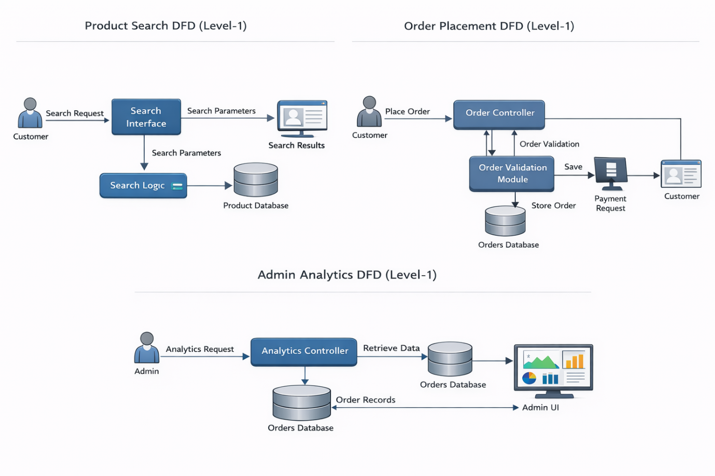





GITHUB LINK
https://github.com/chaitanya1718/ROOT-ORIGIN

DEPLOYED LINK
https://root-origin.vercel.app/

Video Presentation
click to view linkedin post

Appendices
The appendices provide additional supporting information related to the Local Business Directory and Product Finder system. The information included in these appendices is not considered part of the core functional requirements of the SRS, but is provided to help understand the system design, tools, and assumptions used during development.

Appendix 1 - Technology Stack and Tools

This appendix describes the technologies and tools used to develop the system.
    - Frontend: React Vite is used to build a responsive and user-friendly interface for customers and business owners.
    - Backend: Node.js with Express is used to implement REST APIs and handle business logic.
    - Database: MongoDB is used to store user accounts, profiles, and product information.
    - Authentication: Supabase Auth is used for secure login and role-based access control.
    - Development Tools: Visual Studio Code, Postman (API testing), Git, and GitHub/GitLab are used for development and version control.
    - Email Services: SMTP (OTP, password reset, invoice delivery)
    - Payments: Razorpay Test Mode (UPI/Card simulation)

Appendix 2 - Assumptions and Future Enhancements

Assumptions
    - Users have access to the internet and a modern web browser.
    - Payments are simulated using Razorpay test mode
    - Product and inventory data is maintained by admin
    - Email delivery depends on SMTP availability

Future Enhancements
    - Real payment verification and settlement
    - Subscription Based Delivery
    - Refund and cancellation workflows
    - Mobile application (Android/iOS)
    - Advanced recommendation system
    - Role-based staff management (delivery/admin roles)
    - Real-time inventory sync

